**Difference Between Basel 1 2 and 3**

February 21, 2017 Posted by [Dili](https://www.differencebetween.com/author/dilini/)

Key Difference – Basel 1 vs 2 vs 3

Basal accords are introduced by Basel Committee of Banking Supervision (BCBS), a committee of banking supervisory authorities that was incorporated by the central bank governors of the Group of Ten (G-10) countries in 1975. The main objective of this committee is to provide guidelines for banking regulations.  BCBS has issued 3 accords named Basel 1, Basel 2 and Basel 3 so far with the intention of enhancing banking credibility by strengthening the banking supervision worldwide.

The key difference between **Basel 1 2 and 3 is that Basel 1 is established to specify a minimum ratio of capital to risk-weighted assets for the banks whereas Basel 2 is established to introduce supervisory responsibilities and to further strengthen the minimum capital requirement and Basel 3 to promote the need for liquidity buffers (an additional layer of equity).**

# What is Basel 1?

Basel 1 was released in July 1988 to provide a framework to address [risk management](https://www.differencebetween.com/difference-between-proactive-and-vs-reactive-risk-management/) from a bank’s capital adequacy perspective. The principle concern here was the capital adequacy of banks. One of the main reasons for the same was the Latin American debt crisis during the early 1980s, where the committee realized that capital ratios of international banks are diminishing over time. A minimum ratio of capital to risk-weighted assets of 8% was stated to be implemented effective from 1992.

Basel 1 also specified the general provisions that can be included in the calculation of the minimum required capital.

E.g. The accord specified guidelines on how to recognize the effects of multilateral netting (an agreement between two or more banks to settle a number of transactions together as it is cost effective and time-saving as opposed to settling them individually) in April 1995.

# What is Basel 2?

The main objective of Basel 2 was to replace the minimum capital requirement with a need to conduct a supervisory review of the bank’s capital adequacy. Basel 2 consist of 3 pillars. They are,

* Minimum capital requirements, which sought to develop and expand the standardised rules set out in the Basel 1
* Supervisory review of an institution’s capital adequacy and internal assessment process
* Effective use of disclosure as a lever to strengthen market discipline and encourage sound banking practices

The new framework was designed with the intention of improving the way regulatory capital requirements reflect underlying risks and to better address the financial innovation that had occurred in recent years. The changes aimed at rewarding and encouraging continued improvements in risk measurement and control.

# What is Basel 3?

The need for an update to Basel 2 was felt especially with the financial collapse of Lehman Brothers – a global financial services company which was declared bankrupt in September 2008. Pitfalls in corporate governance and risk management have led to the development of this accord which will be effective from 2019 onwards. The banking sector entered the financial crisis with too much leverage and inadequate liquidity buffers. Thus, the main objective of Basel 3 is to specify an additional layer of common equity (a capital conservation buffer) for banks. When breached, restricts payouts to help meet the minimum common equity requirement. Additionally, the following guidelines are also included in Basel 3.

* A countercyclical capital buffer, which places restrictions on participation by banks in system-wide credit booms with the aim of reducing their losses in credit busts
* A [leverage](https://www.differencebetween.com/difference-between-gearing-and-vs-leverage/) ratio – a minimum amount of loss-absorbing capital relative to all of a bank’s assets and off-balance sheet exposures regardless of risk weighting
* [Liquidity](https://www.differencebetween.com/difference-between-profitability-and-vs-liquidity/) requirements – a minimum liquidity ratio, the Liquidity Coverage Ratio (LCR), intended to provide enough cash to cover funding needs over a 30-day period of stress; a longer-term ratio, the Net Stable Funding Ratio (NSFR), intended to address maturity mismatches over the entire balance sheet
* Additional proposals for systemically important banks, including requirements for supplementary capital, augmented contingent capital and strengthened arrangements for cross-border supervision and resolution

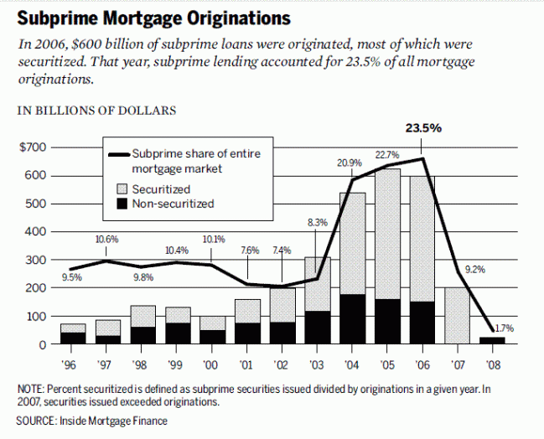

Figure _1: Banks’ lending criteria was the main contributor to the financial crisis in 2008

# What is the difference between Basel 1 2 and 3?

|  |  |
| --- | --- |
| **Basel 1 vs 2 vs 3** | |
| Basel 1 | Basel 1 was formed with the main objective of enumerating a minimum capital requirement for banks. |
| Basel 2 | Basel 2 was established to introduce supervisory responsibilities and to further strengthen the minimum capital requirement. |
| Basel 3 | Focus of Basel 3 was to specify an additional buffer of equity to be maintained by banks. |
| **Risk Focus** | |
| Basel 1 | Basel 1 has the minimal risk focus out of the 3 accords. |
| Basel 2 | Basel 2 introduced a 3 pillar approach to risk management. |
| Basel 3 | Assessment of liquidity risk in addition to the risks set out in Basel 2 was introduced by Basel 3. |
| **Risks Considered** | |
| Basel 1 | Only credit risk is considered in Basel 1. |
| Basel 2 | Basel 2 includes a wide range of risks including operational, strategic and reputational risks. |
| Basel 3 | Basel 3 includes liquidity risks in addition to the risks introduced by Basel 2. |
| **Predictability of Future Risks** | |
| Basel 1 | Basel 1 is backward-looking as it only considered the assets in the current portfolio of banks. |
| Basel 2 | Basel 2 is forward-looking compared to Basel 1 since the capital calculation is risk-sensitive. |
| Basel 3 | Basel 3 is forward looking as macroeconomic environmental factors are considered in addition to the individual bank criteria. |

# Summary – Basel 1 vs 2 vs 3

The difference between Basel 1 2 and 3 accords are mainly due to the differences between their objectives with which they were established to achieve. Even though they are widely different in the standards and requirements they presented, all 3 are navigated in such a way to manage banking risks in light of the swiftly changing international business environments. With the advancements in globalization, banks are interrelated everywhere in the world. If banks take uncalculated risks, disastrous situations can arise due to the massive amount of funds involved and the negative impact can be soon dispersed among many nations. The financial crisis that started on 2008 that caused a substantial economic loss is the timeliest example of this.

Reference:  
1. “History of the Basel Committee.” History of the Basel Committee. N.p., 09 Oct. 2014. Web. 16 Feb. 2017.  
2. “Case Study: The Collapse of Lehman Brothers.” Investopedia. N.p., 03 Mar. 2016. Web. 16 Feb. 2017.  
3. “Basel Accord.” Investopedia. N.p., 15 May 2007. Web. 20 Feb. 2017.  
4. Amadeo, Kimberly. “What Caused the 2008 Financial Crisis and Could It Happen Again?” The Balance. N.p., n.d. Web. 20 Feb. 2017.

Image Courtesy:  
1. “Subprime mortgage originations, 1996-2008″By National Commission on the Causes of the Financial and Economic Crisis in the United States – Final Report of the National Commission on the Causes of the Financial and Economic Crisis in the United States, p.70 figure 5.2 (Public Domain) via [Commons Wikimedia](https://commons.wikimedia.org/w/index.php?curid=26535418)